Name:________________ /33

**Rocks Practical Test**

**Practical Section**

**Station 1 3**

What type of rock is this?

How can you tell?

How were the features you described above formed?

**Station 2 3**

What type of rock is this?

How can you tell?

How were the features you described above formed?

**Station 3 3**

What type of rock is this?

How can you tell?

How were the features you described above formed?

**Station 4 3**

What type of rock is this?

How can you tell?

How were the features you described above formed?

**Station 5 3**

What type of sedimentary rock is this?

How can you tell?

How were the features you described above formed?

**Seated Section**

1. Write the correct definition in each space. 7

______________________ Hot molten rock below the earth’s surface

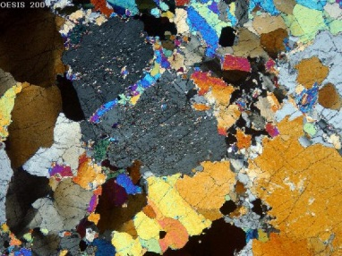______________________ Hot molten rock that is above the earth’s surface

______________________ The type of crystals shown here

______________________ The strongest and hardest of the rock types

______________________ The type of rock you may find a fossil in.

______________________ Type of rock where precious stones may be found

______________________ Sedimentary rock formed from long dead living organisms

2. Fill in the following table: 5

|  |  |
| --- | --- |
| **Use** | **Best type of rock for this purpose** |
| Sculptures, floors and walls |  |
| Cleaning dead skin off your feet or for shaping nails |  |
| Paving and garden walls |  |
| Energy supply |  |
| Buildings and monuments |  |

3. Inside each arrow write what processes must occur for one rock type to change into another. 6

**Igneous Rock**

**Metamorphic**

**Rock**

**Sedimentary Rock**

Teachers Notes

Station 1

An extrusive Igneous rock with small crystals

Station 2

A sedimentary rock

Station 3

An intrusive Igneous Rock with large crystals

Station 4

A metamorphic Rock

Station 5

A clastic sedimentary rock showing layers